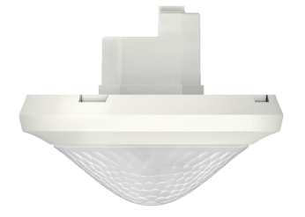
Tender text

Presence sensor theRonda S360 DALI-2 S UP WH
Order No. white: 2080590

Features:
- Passive infrared presence sensor DALI-2 for ceiling installation in flush-mounted box
- This device provides information about presence and brightness in the form of a DALI telegram in line with IEC 62386 Part 303/304
- Circular detection area 360°, moving up to 64 m² (Ø 9 m)
- Area restriction with cover clips (optional)
- 1 instance for presence
- Mixed light measurement
- 1 instance for brightness
- Easy to calibrate brightness measurement
- Test mode for checking function and detection area
- Configurable detection sensitivity
- Can be configured via DALI bus or remote control
- The "theSenda S" or "theSenda B" user remote controls can be used to dim or switch the lamps, to control the blinds, or to execute additional functions via the higher-level control.
- Nice design with exchangeable bezel frames in two colours
- Ceiling installation in flush-mounted box
- Surface-mounted installation possible with surface frame 110A (optional)
- "theSenda B" app remote control (optional) and corresponding "theSenda Plug" app
(for iOS/Android)
- This device corresponds to EN 60669-2-5 and IEC 62386-101/103/303/304

Technical data:
Operating voltage: DALI (in accordance with IEC 62386-101): 10 V – 22.5 V
Power input: max. 10 mA
Stationary detection area: Ø 4 m (IH 3 m)
Moving detection area: Ø 8 m tangential, Ø 4 m radial (IH 3 m)
Recommended installation height IH: 2 – 3 m/max. 4 m
Light measurement: approx. 10 – 10,000 lux
Protection rating: IP 54 (when installed)
Operating temperature: -15 °C to +50 °C
Dimensions: Ø 110 mm, installation depth 37 mm
Connection type: screw terminals / max. 2 x 2.5 mm²

Optional accessories:

theSenda B universal remote control
User remote control with integrated luxmeter.
Remote control for installers: The free theSenda Plug app (for iOS/Android) is easy to use for commissioning or adjusting the parameters. Parameter sets can be saved and named in a customer-specific way and exported for archiving, for instance via email.

Order No.: 9070985

theSenda P service remote control
Order No.: 9070910

theSenda S user remote control
Order No.: 9070911

Surface frame 110A
Order no. white: 9070912 (surface frame 110A WH)
Order No. grey: 9070913 (surface frame 110A GR)

Bezel frame cover 110 GR
Order No. grey: 9070591

Ceiling installation socket 68A
Drill diameter 68 mm
Order No.: 9070992

Cover clip for area restriction
5 pieces
Order No.: 9070921

